**London Business School**

JOB DESCRIPTION

**Job Title Reports to Department**

|  |  |  |
| --- | --- | --- |
| **AV Support Engineer** | | |
| **AV Support Manager** | | |
| **Customer Services, Technology** | | |
| **Business Services** |  | **3** |

**Job Family**

**About the School**

At London Business School, we strive to have a profound impact on the way the world does business and the way business impacts the world. Our departments work hard to ensure that we are continually delivering a world-class service, academic excellence and that our course offering maintains our place as a leading business school.

With thought-leading faculty and dynamic learning solutions, we empower both businesses and individuals by offering a transformational learning experience that will broaden their professional knowledge and global mindset. As well as offering postgraduate courses for the business leaders of the future, we run open and customised executive courses for professionals and corporate clients that help leaders identify the future focus and strategic direction of their businesses.

With London in our hearts, we draw from its status as a financial, entrepreneurial, and cultural hub to attract a diverse range of students and faculty, creating an abundance of opportunities to network with industry experts and alumni worldwide.

**About the Department**

The LBS Technology department is responsible for delivering and supporting all digital, data, and technology solutions required for the effective running of London Business School.

We provide specialist capability in Technology Service Delivery, Software Development, Digital Solutions Delivery, Teaching and Learning Technology, Platform Integration, Data Management, Cyber Security, Project Delivery, Business Change and Enterprise Architecture.

Our customers span our staff, faculty, prospective and current students, and participants, alongside our significant global alumni community. Our role in Technology is to ensure the highest quality, reliable and seamless digital experience to our end users.

## Job Purpose

To provide customer facing technical support and advice to all members of the school community (staff, faculty, students, executive participants and alumni) primarily during teaching and events. Manage any health and safety issue relating to the audio and visual systems in the School’s physical teaching environment. Respond to any emergency calls within agreed SLA.

To include the provision of hardware and software support on AV facilities, hybrid teaching and events, and IT support where required. Support recording and editing of digital video footage for distribution to faculty and participants.

Act as a point of contact for gathering requirements and set up onsite and offsite events with various microphones, camera equipment, projection, and relay screens. Will include operating live audio and video mixing on occasion, achieving desired balance of sound, mixing, and / or dubbing.

Conducting checks of the teaching spaces prior to teaching sessions.

Manage and maintain teaching facilities across campus including diagnosing, configuring, and replacing AV systems and reporting faults. This entails checking the operation, and correct functioning and positioning of projectors, cameras, and sound equipment such as speakers, microphones, and recording devices.

Read and interpret blueprints, floor plans and technical schematics and support networked AV solutions in a higher education or enterprise environment. Troubleshoot, isolate, and resolve control system issues, namely Crestron. Demonstrate technical understanding of video conference standards and protocols.

Working hours on a shift basis covering Monday to Saturday. Based on 35 hours per week standard, shift cover between 7am - 7.30pm) with ad-hoc requirements for evening, Sunday, and Bank holiday cover.

**Key Areas of accountability and Key Performance Indicators (KPis)**

**Key areas of accountability:**

# Delivery and Support

* Apply specialist technical knowledge across a range of different areas to deliver required services in line with defined processes, escalating queries, or tasks if outside own technical knowledge and/or standard procedure for own area.
* Respond to requests from **all** stakeholders, providing specialist advice to deliver the information and/or understanding they require and provide an excellent service.
* Resolve operational day-to-day issues referred from across the School, ensuring an efficient and first-class service is extended to all stakeholders.
* Design and develop materials and policy guidance, with supervision from more senior colleagues, for use in the provision of an efficient and effective business support service.
* Provide training to colleagues or stakeholders on an area of specialism to upskill and educate others in the business support services provided.

# Analysis and Reporting

* Independently collate, cleanse and analyse data, and make recommendations based on analysis to support the department's decision-making process.
* Liaise across the team and other departments to prepare reports to inform review, planning and decision-making.

# Compliance

* Undertake investigations and inspections of data, processes and working practices in accordance with established procedure to identify actual/potential compliance issues and recommend appropriate action.

# Contractor Management

* Oversee on boarding of contractors who are delivering services for an area of specialism for London Business School so that they are aware of the policies, procedures and key deliverables.

# Collaboration

* Collaborate closely with team members and other departments across the School to enable cross department working, to raise the team's profile, and to drive consistency of approach/standards through the wider School, thereby enabling effective service delivery.

# Project Management

* Plan and deliver a range of straightforward projects, and/or contribute to more complex projects with guidance from more senior colleagues, to ensure delivery against project time, cost and quality standards, and targets.

# Financial Management

* Monitor and review financial activity for own area of specialism to ensure the accurate completion of standard financial processes within budget and the provision of up-to-date information to support decision making.

# Process Improvement

* Monitor processes, systems, and practices within area of specialism, plan and carry out regular reviews to identify opportunities for improvement considering changing needs, feedback and/or current best practice thinking; follow through on improvements once agreed.

# People Management

* Please read the people management accountabilities section at the start of this Job Family document and refer to the most appropriate level based on team size or level.

# Change Management

* Champion change by role modelling the behaviour expected from all colleagues and follow through on new activities or actions brought about change to help support its successful implementation.

**KPls:**

* Delivery of high-quality service in area of specialism.
* Area/team compliance with necessary regulations/processes.
* Production of high-quality reports, with the identification of trends and issues.
* Timely and robust onboarding of contractors.
* Projects delivered on time, on budget and to quality standards and targets.
* Development of relationships within and outside the team, and positive feedback from colleagues.
* Improvements to processes and procedures in own area of specialism.
* Up-to-date and accurate financial information for own service area.

**Knowledge/Qualifications/Skills/Experience required**

* Bachelor's degree or equivalent experience.
* Desirable to have a specialist qualification. Avixa CTS, Creston Technician, Q-SYS 1, Dante 1, for example.
* May be working towards relevant professional qualification.
* Knowledge of networked AV Systems, server architecture.
* Knowledge of common switching, distribution, audio, and control system products, namely Crestron.
* Good communication skills and the ability to break down technical issues and explain them in layman's terms.
* Experience of using software related to own area of specialism to extract, analyse and report on data.
* Experience in supporting video assisted technology in teaching, such as lecture capture and web video conferencing.
* Experience supporting end users in their use of hardware and software (MS Teams, Zoom) for remote learning, lecture capture and live streaming.
* Support live event experience (audio, video, streaming).
* Good project management skills.
* Excellent organisational skills and meticulous attention to detail.
* Strong analytical and problem-solving skills.
* Positive experience of working within a customer-services orientated environment.
* Budget management experience

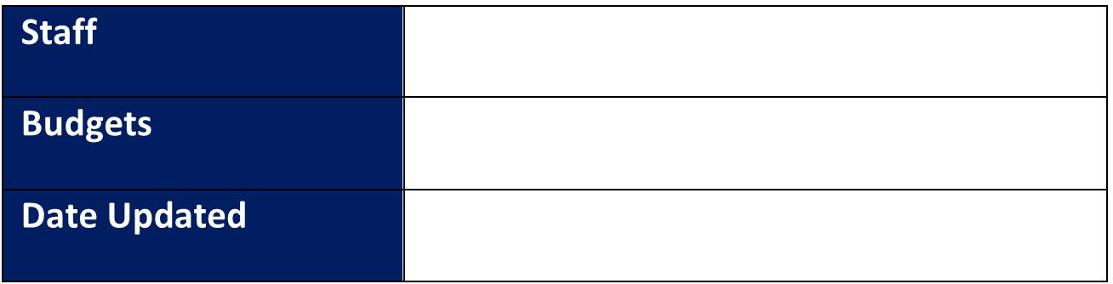

No direct budget management, requirement to raise PO’s

04 / 06 / 2024

No line management